Lab 3 - Create a Spring Boot Java Microservice with STS

* Step 1: Launch STS4
* Open STS, right-click within the **Project Explorer** window, navigate to **New** | **Project**, and
* Step 2: Launch Spring Starter Project
* select **Spring Starter Project**, and click on **Next**:
* Spring Starter Project is a basic template wizard that provides a number of other starter libraries to select from.
* Type the project name as module2.bootrest or any other name of your choice. It is important to choose the packaging as JAR. In traditional web applications, a war file is created and then deployed to a servlet container, where Spring Boot packages all the dependencies to a self-contained, autonomous JAR file with an embedded HTTP listener.
* Select 1.8 under **Java Version**. Java 1.8 is recommended for Spring 4 applications. Change the other Maven properties such as **Group**, **Artifact**, and **Package**, as shown in the following screenshot: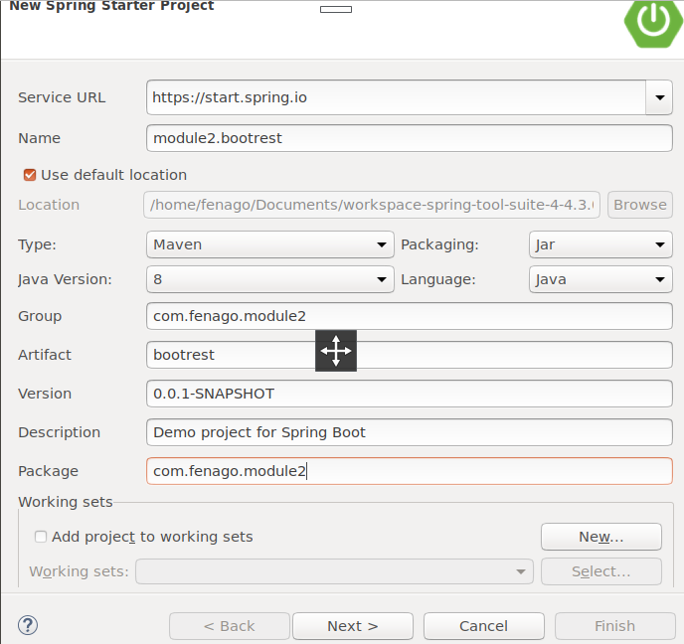
* Once completed, click on **Next**.
* The wizard will show the library options. In this case, as the REST service is developed, select **Web** under **Web**. This is an interesting step that tells Spring Boot that a Spring MVC web application is being developed so that Spring Boot can include the necessary libraries, including Tomcat as the HTTP listener and other configurations, as required:
* 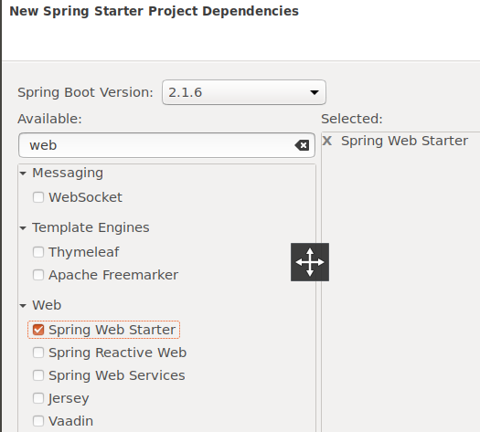
* Click on **Finish**.
* This will generate a project named module2.bootrest in **Project Explorer** in STS:
* 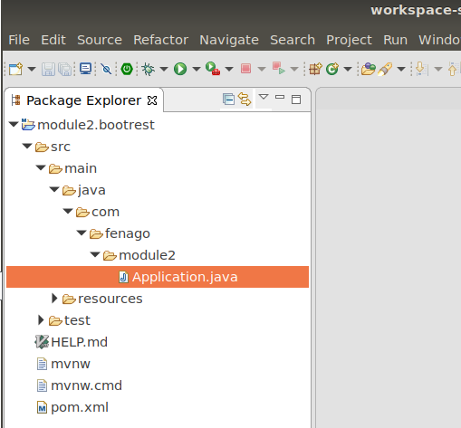
* Take a moment to examine the generated application. Files that are of interest are:
  + pom.xml
  + Application.java
  + Application.properties
  + ApplicationTests.java